Matching Resumes with Job Descripitions

:Prepared by students
Shefaa saeed Moder alsaleh

Supervised by:

Dr.Majida Al-bakkour Eng.Wissam Al-Sohli

Abstract 7
Chapter 1: Introduction 8
1.1 General Background 9
1.2 Problem Statement 11
1.3 Research Objectives 12
1.4 Significance of the Research 13
1.5 The Complexity of Human Language and Resume Analysis Challenges 14
1.6 Limitations of Traditional Resume Screening Systems 15
1.7 Why a Hybrid Semantic and Machine Learning Approach is the Optimal Solution 15
1.8 Expected Impact of the Proposed Solution 16
1.10 Report Organization 16
Chapter 2: Literature Review 18
Summrary of reference Studies 20
Chapter 3: Project Methodology 21
3.1 Dataset Description 22
3.2 Data Representation 22
3.3 Feature Engineering 23
3.4 Target Variable Transformation 24
3.5 Evaluation Metrics 24
Chapter 4: Implementation Tools 26
4.1 Implementation Environment and Tools 27
4.1.1 Python Programming Language 27
4.1.2 Google Colab Platform and Environment 28
4.1.3 Transformer Models in Natural Language Processing 29
4.1.4 Attention and Self-Attention Mechanisms 29
4.1.5 Transformer Model Architecture 30
4.1.6 Sentence-BERT and Semantic Similarity 30
4.1.7 Software Libraries and Their Functional Roles 31
4.1.8 Tool Integration and Portability 34
Chapter 5: Project Implementation 35
5.1 Scientific Methodology and Workflow 36
5.1.1 Data Collection and Preparation 36
5.1.2 Information Extraction 37
5.1.3 Feature Engineering 38
5.1.4 Semantic Representation 39
5.1.5 Constructing the Suitability Predictive Model 39
5.1.6 Evaluation and Analysis 40
5.2 Detailed System Architecture 40
5.2.1 Input Layer 40
5.2.2 Semantic and Structural Encoding Layer 40
5.2.3 Matching Prediction Layer (Ensemble Head) 41
5.3 Model Hyperparameters 41
5.4 Functional Model Pipeline Layers 43
Chapter 6: Conclusions and Results 45
6.1 Presentation of Result 46
6.1.1 Baseline Experiment: Standalone Optimized XGBoost Model 46
6.1.2 Main Experiment: Enhanced Weighted Voting Ensemble 46
6.2 Interpretation of Results 48
6.3 Comparative Analysis 49
6.4 Engineering Interpretation of the System Behavior 51
6.5 Strengths and Potential Constraints 51
6.6 Future Enhancements 51
6.7 Future Research Orientations 52
6.8 Conclusion 52
Table of content 53
References 57

Abstract

This project addresses the challenging problem of evaluating resumes (CVs) and comparing them with job descriptions (JDs) to enhance the recruitment pipeline and support automated decision-making within organizations. Traditional recruitment methodologies rely heavily on manual screening or keyword-based Applicant Tracking Systems (ATS) that frequently fail to capture the contextual and semantic nuances of text, leading to either the exclusion of highly qualified talent or the suboptimal selection of candidates.
To overcome these limitations, this project develops an intelligent talent retrieval system based on advanced Natural Language Processing (NLP) and machine learning techniques. The core framework leverages state-of-the-art Transformer models, specifically Sentence-BERT (SBERT), to encode raw text into unified, low-dimensional dense vector representations.
The challenge is formulated as a Supervised Classification and Ranking task. By extracting and consolidating specialized high-level features—such as exact experience gaps, Jaccard matching ratios, and domain-specific skill profiles—the system constructs an optimized, consolidated data matrix.
The decision-making architecture is powered by an enhanced, cost-sensitive Weighted Voting Ensemble consisting of optimized gradient boosters (XGBoost) and random forests operating under a soft-voting probability head. This ensemble configuration successfully addresses data imbalances and generates fine-grained suitability confidence scores bounded between 0.0 and 1.0, allowing HR professionals to rank candidates objectively based on statistical probability.
The empirical results demonstrate robust predictive performance, with the enhanced voting ensemble achieving a peak Classification Accuracy of 72.69% on unseen validation data. The system significantly minimized False Negative errors, proving its stability and highly sensitive recall capabilities in real-world recruitment environments where missing ideal talent carries high institutional costs.
Ultimately, this intelligent pipeline contributes to substantially reducing the manual time and operational costs associated with initial talent screening, while mitigating human bias and promoting fairness. Furthermore, it establishes a transparent blueprint for next-generation recruitment technologies, opening promising future research directions such as integrating Generative Large Language Model (LLM) agents, deploying multi-task retrieval learning, and incorporating temporal career transition patterns.

Chapter 1: Introduction

Introduction

1.1 General Background

In recent decades, the world has witnessed rapid advancements in computing technologies and Artificial Intelligence (AI), leading to radical changes in data management and decision-making processes across various domains. Intelligent systems have become an essential part of the infrastructure in sectors such as healthcare, education, industry, and human resources, where they are utilized to analyze massive amounts of data much faster and more accurately than traditional methods.

Artificial Intelligence is one of the most evolving and influential branches of computer science, aiming to design systems capable of simulating human cognitive abilities, such as comprehension, learning, reasoning, and decision-making. Among AI subfields, Natural Language Processing (NLP) has emerged as a pivotal area due to its ability to process written texts and human language, transforming them into computationally processable representations.

In this context, NLP technologies have seen significant progress, particularly with the advent of Deep Learning and Transformer models, which created a paradigm shift in understanding the semantic meaning of texts. These models enabled intelligent systems to move beyond traditional keyword-based methods toward a deeper, context-aware comprehension.

The recruitment sector heavily relies on textual data, as resumes contain unstructured information encompassing academic qualifications, professional experiences, technical and soft skills, among other vital details. Conversely, job descriptions outline specific requirements expressed in varying linguistic structures, making the manual matching process highly complex.

In traditional recruitment systems, resume screening relies heavily on human evaluation, demanding substantial time and effort, alongside the potential for human error or unintentional bias. Furthermore, the continuous increase in job applicants, especially with the proliferation of online hiring platforms, has rendered this process more complicated and less efficient.

Consequently, there is a pressing need to develop intelligent systems capable of automating the resume evaluation process by analyzing texts semantically, extracting relevant information, and measuring the alignment between a resume and job requirements objectively and accurately. Utilizing AI and NLP in this domain is a fundamental step toward improving recruitment efficiency and ensuring fairness and transparency in candidate selection.
Project Overview
This project focuses on designing and developing a smart, hybrid recruitment system that leverages both Natural Language Processing and advanced Machine Learning algorithms to automate and optimize the resume screening process. The proposed system analyzes the full text of both the resume and the job description, extracting semantic representations to capture the true contextual meaning of the content.

Unlike standard similarity-based systems, this project adopts a hybrid architecture. It utilizes modern Transformer models to calculate semantic similarity, and then integrates this textual analysis with critical numerical features, such as the required and actual years of experience. These combined features are subsequently fed into an advanced classification algorithm, specifically XGBoost, which evaluates the complex relationship between linguistic skills and practical experience. By shifting the problem from simple semantic similarity regression to a comprehensive multi-feature classification task, the system provides a highly accurate, objective evaluation to support decision-makers in the candidate selection process.

1.2 Problem Statement

The evaluation of resumes is one of the most complex and sensitive stages in recruitment systems, primarily because it relies on unstructured textual data and diverse linguistic expressions among applicants. Resumes often contain identical information presented in various linguistic formats, and candidates may use different terminology to describe the exact same skills and experiences. This discrepancy makes accurate matching exceedingly difficult when relying on traditional methods.

The core problem lies in the fact that most conventional screening systems depend on exact keyword matching. This limited approach fails to capture the true semantic meaning of the text and often leads to the unwarranted rejection of highly qualified candidates simply due to a lack of literal word matches. Furthermore, manual resume screening demands immense time and effort, and it is highly susceptible to human error and unintentional bias, particularly when handling massive volumes of applications.

This issue is further exacerbated by the expansion of online recruitment platforms, where a single organization might receive hundreds or thousands of resumes for a single vacancy, rendering manual evaluation highly impractical. However, while recent semantic models address the linguistic gap, they introduce a new problem: they often evaluate candidates based purely on terminology, completely failing to account for strict numerical constraints, such as the required years of practical experience. This semantic limitation can lead to illogical hiring recommendations, such as highly ranking a fresh graduate for a senior managerial role.

Consequently, the research problem centers on the urgent need for a hybrid intelligent system. This system must not only comprehend texts semantically but also intelligently balance these linguistic capabilities with hard numerical constraints. By doing so, it can provide an objective, accurate, and multi-dimensional evaluation that minimizes bias, eliminates logical errors, and significantly maximizes recruitment efficiency.

1.3 Research Objectives

This project aims to achieve a set of primary objectives, notably:
Designing an intelligent recruitment system that leverages both Natural Language Processing (NLP) techniques and Machine Learning algorithms to evaluate resumes.

Modeling the resume-job description matching process not merely as a text-similarity task, but as a comprehensive, multi-feature classification problem.

Utilizing advanced Transformer models (e.g., SBERT) to extract highly accurate semantic representations of unstructured textual data.

Integrating semantic similarity scores with strict numerical constraints—specifically required and actual years of experience—to engineer robust features for the classification model.

Significantly improving the accuracy and logical consistency of resume-job matching compared to traditional keyword-based or purely semantic methods.

Reducing human bias and enhancing both the efficiency and fairness of the hiring process.

1.4 Significance of the Research

The significance of this research stems from its approach to a complex, real-world challenge facing modern organizations: the difficulty of evaluating resumes accurately and fairly amidst high volumes of applicants with diverse backgrounds. Recruitment is not merely about filling a vacancy; it represents a strategic decision that directly impacts the long-term performance and stability of an organization.

The severity of this issue escalates when traditional evaluation mechanisms lead to inaccurate decisions, such as rejecting highly qualified candidates (False Negatives) or advancing unsuitable ones (False Positives), resulting in substantial financial and operational losses. Furthermore, human bias—whether conscious or unconscious—can negatively affect equal opportunity principles and diminish the fairness of the hiring process.

The hybrid solution proposed in this research offers a substantial paradigm shift. By relying on an intelligent system capable of both understanding texts semantically and rigorously evaluating numerical qualifications, it provides an objective, multi-dimensional score reflecting the true compatibility between a candidate and a role. This approach expedites the recruitment process, alleviates the burden on human resources departments, and elevates the quality of hiring decisions. Ultimately, implementing this system lays the groundwork for developing more advanced and transparent Applicant Tracking Systems (ATS) aligned with digital transformation demands.

1.5 The Complexity of Human Language and Resume Analysis Challenges

Human language is inherently complex and flexible. The same underlying concept can be expressed through various linguistic structures and multiple synonyms, further complicated by industry-specific jargon and acronyms. This complexity is glaringly evident in resumes, as writing styles vary significantly from person to person based on cultural background, professional experience, and presentation preferences.

Resumes typically consist of unstructured data—such as descriptions of professional experiences and soft skills—that do not adhere to a standardized template. Crucial information may be dispersed across different sections or implied rather than explicitly stated, making extraction and analysis exceedingly difficult using traditional rule-based methods. These linguistic characteristics compound the difficulty of automated evaluation, emphasizing the absolute necessity for models capable of deep contextual and semantic understanding, rather than relying on superficial matching.

1.6 Limitations of Traditional Resume Screening Systems

Many traditional resume screening systems, commonly known as Applicant Tracking Systems (ATS), rely on rudimentary techniques such as exact keyword matching or predefined rigid rules. Despite the speed and ease of implementing these methods, they suffer from a severe deficiency in comprehending the true meaning of texts.

These systems frequently result in the automatic rejection of highly qualified candidates simply because they did not use the exact terminology found in the job description, even if their practical experience perfectly aligns with the role. Furthermore, these methods completely ignore the general context of the text and the nuanced relationships between different skills, which drastically reduces the accuracy of the evaluation process and negatively impacts the quality of hiring decisions.

1.7 Why a Hybrid Semantic and Machine Learning Approach is the Optimal Solution

Relying solely on semantic similarity represents a significant leap in processing recruitment data by solving the linguistic communication gap. However, semantic analysis alone remains insufficient, as it evaluates terminology without verifying quantitative qualifications. Therefore, adopting a hybrid methodology that combines semantic text similarity with an advanced classification model represents the most robust and complete solution for the recruitment problem.

Instead of making a rigid binary decision based on keywords, this hybrid approach evaluates the semantic alignment of candidate skills alongside strict numerical criteria, such as the required and actual years of experience. By utilizing advanced algorithms that output detailed probabilistic scores, the system provides a continuous evaluation metric that reflects the true, multidimensional compatibility of a candidate. This allows decision-makers to rank applicants accurately based on a holistic view of both their knowledge and practical tenure, reflecting the complex reality of professional recruitment.

1.8 Expected Impact of the Proposed Solution

The proposed system is expected to make a tangible impact on institutional hiring mechanisms by significantly reducing the time required to screen massive volumes of resumes, alleviating the administrative burden on human resources teams, and elevating the overall quality of hiring decisions. Relying on an intelligent, multi-featured evaluation helps minimize human bias and reinforces the principles of fairness and equal opportunity among applicants.

Additionally, this hybrid solution provides a solid foundation for developing smarter, more transparent, and highly adaptable recruitment systems in the future. Such systems can seamlessly integrate with modern digital hiring platforms, keeping pace with the demands of digital transformation and actively contributing to the efficiency of the contemporary labor market.

1.10 Report Organization
This report is organized into five primary chapters, each addressing a distinct aspect of the project lifecycle in a logical and progressive manner. The following overview provides a structural blueprint of the report as it has been constituted in accordance with academic standards and the guidance of the supervising faculty:
Chapter 1 — Introduction: The present chapter establishes the foundational context of the research. It introduces the problem domain, delineates the research objectives, and articulates the significance of developing an intelligent, hybrid resume-to-job-description matching system. The chapter concludes with this organizational overview, guiding the reader through the report's overall structure.
Chapter 2 — Literature Review: This chapter presents a comprehensive survey of prior academic and industry research relevant to the domain of automated resume screening, CV-JD matching, and NLP-driven talent retrieval systems. It critically analyzes previous methodologies, identifies the research gaps addressed by this project, and positions the current work within the broader scientific landscape.
Chapter 3 — Project Methodology: This chapter details the complete methodological framework of the project. It describes the dataset utilized, including its structure and sourcing, the full data preprocessing pipeline, the feature engineering phase, the semantic representation strategy using SBERT, and the construction of the binary classification target variable. The chapter provides a thorough account of the tools and technologies employed, and the processing phases that transform raw textual data into a machine-learning-ready feature matrix.
Chapter 4 — Results and Evaluation: This chapter presents the empirical outcomes of the classification experiments. It begins by formally defining the evaluation metrics — Accuracy, Precision, Recall, and F1-Score — applied to assess model performance. It then presents and interprets the results from both the baseline XGBoost experiment and the Enhanced Weighted Voting Ensemble, supported by visual artifacts such as Learning Curves and Confusion Matrices.
Chapter 5 — Conclusions and Recommendations: The final chapter synthesizes the findings of the project, articulates the system's principal strengths and current limitations, and presents concrete recommendations for future research and system enhancements

Chapter 2: Literature Review

Literature Review

Evaluating resumes and screening job candidates is considered one of the most time-consuming tasks for recruitment professionals, particularly given the rapid growth in applicant volumes and the intense competition in the labor market. This has driven organizations to seek technological solutions that enable the automation of the evaluation process, facilitating faster and more accurate decision-making. In this context, numerous studies have emerged addressing the resume screening process utilizing Natural Language Processing (NLP), Machine Learning (ML), Deep Learning (DL), Transformer models, and Large Language Model (LLM) agents.
These studies aim to tackle several key challenges, most notably: the variance in linguistic styles used in resume writing, the discrepancy in terminology between candidates and employers, the difficulty of accurately extracting skills and experiences, and the inability of traditional systems to comprehend the semantic context of texts. Accordingly, this section serves as a review of relevant research literature, analyzing several studies that approached the same problem using diverse methodologies and tools, ranging from traditional machine learning models to modern systems based on large language models.
The primary objective of this section is to establish a methodological framework for the research problem, illustrate the scientific evolution in this domain, and identify the specific research gaps that our project addresses. Most notably, this research addresses the critical gap of over-relying on purely semantic evaluations while failing to integrate strict numerical constraints, such as years of experience. By comparing previous studies in terms of their methodologies, datasets, applied technologies, evaluation metrics, and final results, this chapter highlights the necessity of adopting a multidimensional, hybrid evaluation approach.

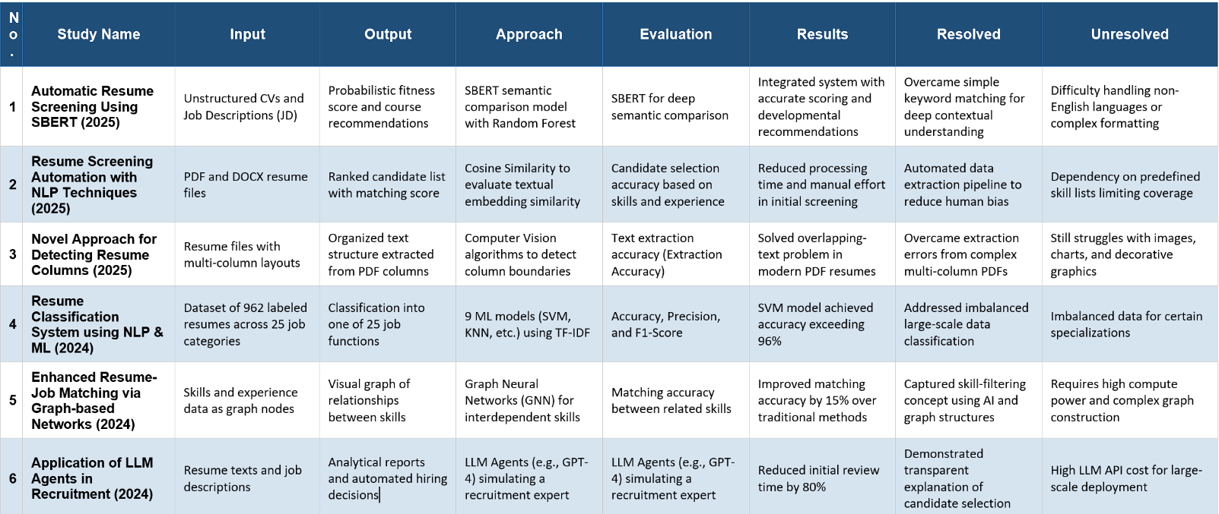
Summrary of reference Studies

Chapter 3: Project Methodology

3.1 Dataset Description
Unlike systems that rely on scraping and parsing raw PDF files, this project utilized a standardized and publicly available dataset sourced from Kaggle, specifically titled "resume data". Utilizing a consolidated dataset ensures higher data integrity and consistency during the training phase. The dataset encompasses paired records representing the two fundamental pillars of the recruitment process: candidate resumes and corresponding job descriptions.

The resume sections contain extracted text covering applicants' professional backgrounds, technical skills, and actual years of experience. Conversely, the job description sections outline the specific requirements, necessary skills, and the minimum required years of experience for the roles. Crucially, the dataset includes a pre-calculated "matched_score" (ranging from 0 to 1) for each pair, which served as the continuous ground truth reflecting the degree of suitability between the candidate and the job.

3.2 Data Representation
To effectively process the information, both the resumes and job descriptions were represented across two distinct levels:

Textual Level: The raw text detailing skills, responsibilities, and qualifications.

Numerical Level: The advanced Sentence-BERT model (all-MiniLM-L6-v2) was employed to transform the raw text of both the resume and the job description into dense numerical vectors (Embeddings) to capture their deep semantic meanings mathematically.

3.3 Feature Engineering
A critical step in transitioning this project from a standard NLP task to a robust Machine Learning solution was the extraction of a focused, highly effective hybrid feature set. Instead of passing hundreds of raw embedding dimensions to the classifier, the data was distilled into four core features (X_smart):

Semantic Similarity: Calculated using Cosine Similarity between the SBERT vectors of the resume and the job description.

Candidate Experience: The actual years of experience possessed by the applicant.

Required Experience: The minimum years of experience demanded by the job description.

Experience Gap: A calculated feature representing the difference between the candidate's experience and the required experience (Gap = Candidate Experience - Required Experience).

3.4 Target Variable Transformation
To align the system with real-world HR decision-making, which ultimately requires a definitive "Hire" or "Reject" outcome, the continuous ground truth "matched_score" was transformed into a binary label. A custom thresholding function was applied where any score below 0.6 was labeled as 0 (Not Fit), and any score equal to or above 0.6 was labeled as 1 (Fit). This transformation effectively converted the task from a regression problem into a Binary Classification problem.

3.5 Evaluation Metrics
Given the binary classification nature of the final model. Instead, the system's performance is evaluated using standard classification metrics:

Accuracy: The overall percentage of correctly classified candidates (both Fit and Not Fit).

Precision: The proportion of candidates predicted as "Fit" who were actually suitable. High precision ensures the system does not recommend unqualified candidates (minimizing False Positives).

Recall: The proportion of actually "Fit" candidates that the system successfully identified. High recall ensures no good candidates are missed (minimizing False Negatives).

F1-Score: The harmonic mean of Precision and Recall, providing a balanced metric, especially crucial when dealing with imbalanced datasets where one class outweighs the other.

Chapter 4: Implementation Tools

4.1 Implementation Environment and Tools
This project was implemented within a development environment relying on scripting and data processing using the Google Colab platform. It leverages modern Artificial Intelligence technologies, specifically Transformer models and semantic sentence representation. This section aims to outline the implementation environment, programming language, and software tools used, in addition to providing the theoretical framework that supports the selection of these specific models and tools.

4.1.1 Python Programming Language
Python was selected as the primary programming language for executing this project due to its widespread adoption in the fields of Artificial Intelligence, Deep Learning, and Natural Language Processing (NLP). Python is characterized by its simple syntax and code readability, making it highly suitable for both academic research and complex applied projects. Furthermore, Python provides a rich ecosystem of specialized software libraries, which facilitated the execution of all project phases within a unified programming environment, from raw data preprocessing and semantic text representation to model training and performance evaluation.

4.1.2 Google Colab Platform and Environment
The Google Colab platform was utilized as the primary execution environment for the project. It provides a cloud-based environment based on interactive Jupyter notebooks, eliminating the need for local setup or advanced hardware infrastructure. This platform allowed for flexible and rapid code execution, data loading, and model experimentation. Google Colab also granted access to hardware accelerators, specifically the NVIDIA Tesla T4 GPU, which was crucial in accelerating the computational processes associated with generating vector embeddings. This acceleration is essential when dealing with computationally heavy language models based on the Transformer architecture.

4.1.3 Transformer Models in Natural Language Processing
The field of Natural Language Processing witnessed a radical evolution with the emergence of Transformer models, which served as a highly effective alternative to traditional sequential models like Recurrent Neural Networks (RNNs) and Long Short-Term Memory networks (LSTMs). Transformers rely on the Self-Attention mechanism, enabling the model to comprehend the complete linguistic context of a text without depending on the sequential order of words. This characteristic is of paramount importance when analyzing relatively long texts such as resumes and job descriptions, where core information is often dispersed across various sections of the document.

4.1.4 Attention and Self-Attention Mechanisms
The Attention Mechanism assigns different weights to words based on their contextual importance within the text. Self-Attention, specifically, allows each word to derive its meaning by referencing the other surrounding words in the sequence. This approach aids in building a rich semantic representation that reflects the conceptual relationships between words, rather than just their order or frequency, making it exceptionally suited for tasks involving semantic understanding and text similarity.

4.1.5 Transformer Model Architecture
The fundamental architecture of the original Transformer model consists of two main components: the Encoder and the Decoder. In this project, only the Encoder component was utilized. The Encoder processes the input texts and transforms them into high-quality, dense numerical representations (Embeddings) that fully capture the overarching context of the text.

4.1.6 Sentence-BERT and Semantic Similarity
Sentence-BERT (SBERT) models are built upon the Transformer architecture and are specifically designed to produce fixed-length representations for entire sentences or complete texts. This approach allows for direct text comparison using mathematical similarity metrics such as Cosine Similarity, making it highly appropriate for evaluating the semantic alignment between a resume and a job description.

4.1.7 Software Libraries and Their Functional Roles
The project relied on a specific set of foundational software libraries, with each library performing a distinct role across the implementation phases:

pandas Library
The pandas library was used to manage the tabular data associated with resumes and job descriptions. This library enabled reading and organizing CSV files, cleaning textual data, handling missing values, and preparing the structural foundation of the dataset before feature engineering.

numpy Library
The numpy library played a pivotal role in handling numerical vectors and arrays, particularly during the feature engineering phase. It was used to manage the mathematical operations required to combine semantic embeddings with numerical features, such as years of experience and the calculated experience gap.

sentence-transformers Library
The sentence-transformers library is a core NLP component of this project. It was utilized to deploy the all-MiniLM-L6-v2 model in order to generate dense embeddings for the texts, represent both the resumes and job descriptions within a unified semantic space, and efficiently support the semantic similarity calculations.

xgboost Library
Unlike systems that rely on basic neural network dense layers, this project utilized the xgboost library to implement the eXtreme Gradient Boosting (XGBoost) classifier. XGBoost served as the primary decision-making engine of the hybrid system. It was responsible for receiving the engineered features (semantic similarity, experience, and gap), handling class imbalances using cost-sensitive learning parameters, and ultimately outputting the final probabilistic classification for each candidate.

scikit-learn Library
The scikit-learn library was employed for data splitting and rigorous statistical evaluation. It was relied upon to split the data into training and testing sets (train_test_split) and to calculate the critical binary classification metrics, including Accuracy, Precision, Recall, F1-Score, and to generate the Confusion Matrix.

matplotlib Library
The matplotlib library was used to visualize data distributions and plot the model's performance curves, aiding in monitoring the model's behavior and ensuring stability during the evaluation phase.

4.1.8 Tool Integration and Portability
The seamless integration of Google Colab, Python, SBERT, and XGBoost aligns this system closely with the environments adopted in modern commercial Applicant Tracking Systems (ATS). This modularity facilitates the future portability of the model into actual production environments or its integration into broader, smart recruitment platforms.

Chapter 5: Project Implementation

5.1 Scientific Methodology and Workflow
This project follows a systematic scientific methodology aimed at transforming unstructured text—such as resumes (CVs) and job descriptions (JDs)—into processed numerical representations. The ultimate goal is to build an intelligent predictive model capable of estimating the job suitability score, addressing the core challenges of CV-JD matching.
The methodology integrates advanced text preprocessing, semantic embedding using state-of-the-art language models, and rigorous feature engineering to construct a highly evaluable predictive system. The implementation workflow is divided into several interconnected phases as detailed below:

5.1.1 Data Collection and Preparation
In the initial phase, a dataset comprising PDF resumes from various technical and managerial domains was compiled, alongside corresponding job descriptions outlining technical skills, experience constraints, and academic qualifications. The PDF files were converted into raw text using specialized text extraction libraries, and the parsed data was structured into unified CSV files.

These structured files contained several primary features, including:
Raw Resume Text

Job Description Text

Reference Match Score (Ground Truth Labels)

Extracted Metadata Fields (Specifically: Skills Profiles and Years of Experience)

The primary objective of this stage was to standardize the data formats, ensuring complete compatibility with the downstream feature engineering and machine learning pipelines.

5.1.2 Information Extraction
Since the raw text data is inherently unstructured, a dual-component pipeline was deployed to extract key professional entities:
- Rule-Based & Pattern-Matching Approach: Utilized regular expressions and linguistic patterns to isolate explicit structured metrics such as years of experience and formal job titles.
- Semantic Model-Based Approach: Employed semantic segmentation to parse highly variable text segments and contextual professional attributes.
This hybrid extraction layer successfully isolated the following feature dimensions:
- Candidate and Job Skills Profiles
- Documented Years of Experience
- Formal Educational Attainment and Degree Levels
- Occupational Domains and Technology Stacks

5.1.3 Feature Engineering
Following data extraction, a rigorous feature engineering phase was executed to transform raw text insights into high-level, discriminative numerical features tailored for the machine learning classifier. These engineered features included:
- Token Intersection Count: The exact number of overlapping technical skills between the candidate and the job requirements.
- Skills Jaccard Similarity: The exact linguistic matching ratio computed via tokenized intersection over union ($|A \cap B| / |A \cup B|$).
- Experience Gap (exp_gap): A calculated delta vector subtracting the minimum required job duration from the candidate's actual years of experience.
- Academic Alignment Score: A categorical verification mapping the candidate's degree level against target institutional requirements.
- Global Semantic Similarity: Global document-level proximity scores captured via contextual embeddings.
This feature space effectively bridges the gap between unstructured textual data and the tabular ensemble learning system.

5.1.4 Semantic Representation
State-of-the-art Sentence-BERT (SBERT) architectures (all-MiniLM-L6-v2) were utilized to generate low-dimensional, fixed-length dense vector representations for:
- Resume Documents (CV Embeddings)
- Job Requirement Profiles (JD Embeddings)
These embeddings map the baseline semantic architecture of the text, allowing the system to compute precise Cosine Similarity measures within a shared vector space, bypassing the limitations of traditional keyword matching.

5.1.5 Constructing the Suitability Predictive Model
The CV-JD matching framework is developed as a Supervised Classification task designed to generate fine-grained probabilistic confidence intervals. The core classification engine relies on a robust Weighted Voting Ensemble consisting of optimized gradient boosters and random forests. By invoking predict_proba, the model generates a precise suitability confidence interval bounded between $0.0$ and $1.0$. This probability serves as the quantitative foundation for the subsequent candidate scoring and ranking module.

5.1.6 Evaluation and Analysis
The system’s generalization capabilities were benchmarked using multidimensional validation frameworks, including:
- Classification Accuracy Metrics: Evaluating overall predictive stability on unseen testing partitions ($X_{test}, y_{test}$).
- Confusion Matrix Profiling: Tracking error distribution rates, with a primary emphasis on reducing False Negatives to prevent overlooking highly qualified talent.
- Ranking Integrity: Measuring the reliability of probability outputs for real-world HR deployment.

5.2 Detailed System Architecture
The proposed intelligent pipeline is structurally divided into three functional layers:

5.2.1 Input Layer
This layer ingests the raw, unstructured resume strings and target job descriptions. It executes standard text cleaning, normalization, case-folding, and punctuation stripping to build a sanitized, reproducible document flow.

5.2.2 Semantic and Structural Encoding Layer
Operating as the data core of the system, this layer simultaneously computes textual representations and structural metadata:
- Generating contextual dense embeddings via SBERT.
- Engineering the high-level tabular data matrices (Experience Gaps and Jaccard metrics).
- Compiling these heterogeneous features into a unified, clean DataFrame (X_smart) optimized for tabular classifiers.

5.2.3 Matching Prediction Layer (Ensemble Head)
This decision engine processes the structured X_smart matrix through a weighted voting committee. The model aggregates the individual probability distributions of the base learners, applying a soft-voting equation where the primary weight is assigned to the optimized XGBoost model. This architecture reflects the structural design paradigms observed in modern, highly scalable industrial talent pipelines such as LinkedIn Talent Matching and the Indeed Hiring Pipeline.

5.3 Model Hyperparameters
Model parameters were fine-tuned via rigorous validation tracking to balance model complexity against overfitting constraints. The optimized configuration matrix is structured as follows:
Component / Algorithm | Hyperparameter | Configured Value / Paradigm
Embedding Engine | Model Architecture | all-MiniLM-L6-v2 (SBERT)
Tabular Matrix Setup | Data Framework | High-Level X_smart DataFrame
XGBoost Engine (xgb_e) | Base Estimators (n_estimators) | 200 Decision Trees
 | Learning Rate ($\eta$) | 0.02 (Conservative Learning)
 | Maximum Tree Depth (max_depth) | 3 (Low complexity constraint)
 | Regularization Criteria | gamma=1, subsample=0.8, colsample_bytree=0.8
 | Class Imbalance Handle | Cost-Sensitive scale_pos_weight
Random Forest (rf_e) | Parameters | n_estimators=200, max_depth=5, class_weight='balanced'
Ensemble Head | Voting Strategy | Soft Voting (Probability Averaging)
 | Decision Weights | weights=[4, 2, 2] (XGB: 4, RF: 2, GB: 2)

5.4 Functional Model Pipeline Layers
The execution flow of the operational pipeline follows a sequential multi-stage transformation:
- Document Embedding Layer: Translates raw textual items into fixed dense semantic representations.
- Metadata Processing Layer: Extracts and structures categorical and discrete numerical properties (experience profiles).
- Smart Fusion Layer (X_smart Matrix): Consolidates contextual textual similarity scores and engineered tabular vectors while enforcing proper index re-alignment via reset_index(drop=True).
- Committee Optimization Layer: Imbalances are resolved using cost-sensitive scaling weights across heterogeneous decision paths.
- Soft-Voting Invariance Head: Aggregates multi-model probabilistic outputs via a weighted confidence function.
- Output Ranking Engine: Filters rows using an acceptance threshold (0.75) and outputs an ordered, human-interpretable Top 10 candidate recommendation list.

Chapter 6: Conclusions and Results

6.1 Presentation of Result
To evaluate the performance of the proposed framework, two primary experimental pipelines were executed using the integrated smart metadata space coupled with Sentence-BERT contextual embeddings. The primary objective was to evaluate the predictive power of a standalone model against the engineered collective decision pipeline.
The evaluation metrics utilized to gauge the system's performance are overall Classification Accuracy, Precision, Recall, and the F1-Score which balances both precision and sensitivity.

6.1.1 Baseline Experiment: Standalone Optimized XGBoost Model
The performance metrics generated by the single baseline XGBoost model settled at an overall Classification Accuracy of 67.18%. In this phase, the standalone model managed to achieve 428 True Positive talent matching retrievals for the suitable class, but suffered from a relatively high error rate, recording 244 False Negative profile

6.1.2 Main Experiment: Enhanced Weighted Voting Ensemble
By deploying the comprehensive hybrid voting head consisting of XGBoost, Random Forest, and Gradient Boosting algorithms weighted at a customized 4:2:2 ratio, the operational capabilities improved substantially. The ensemble pipeline achieved an optimal Classification Accuracy of 72.69%. Furthermore, the True Positive retrievals for the suitable class increased to 499 profiles, while the False Negative error rate was reduced significantly to 173 profiles.

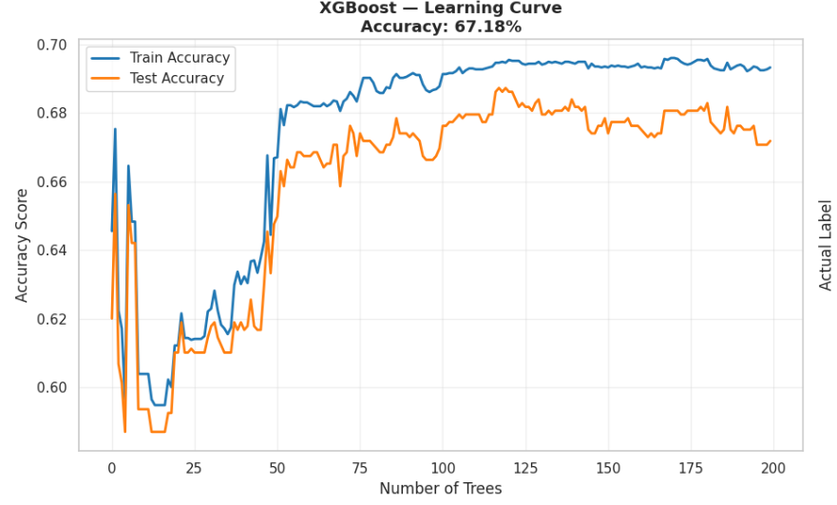
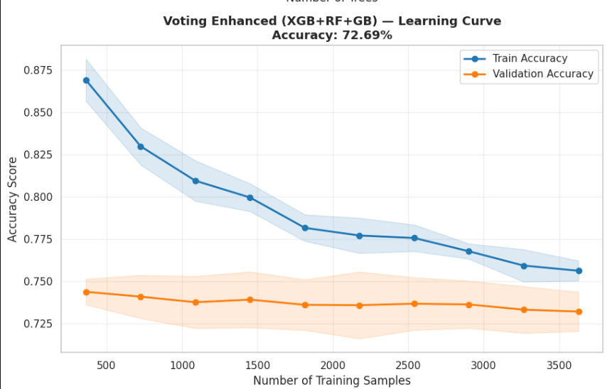

6.2 Interpretation of Results
The statistical behavior indicates that the enhanced weighted ensemble effectively learned the non-linear semantic mapping between resume structures and job constraints. The marked reduction in False Negative errors, dropping from 244 to 173, implies that the Recall capability of the system is highly sensitive.
In industrial Applicant Tracking Systems, high Recall is crucial because it guarantees that the pipeline minimizes the risk of rejecting elite corporate talent due to vocabulary variations. Furthermore, the stabilization of the training and validation tracking bounds demonstrates that the stochastic regularization features successfully prevented overfitting.

6.3 Comparative Analysis
An analytical contrast between the baseline and the enhanced models highlights two critical structural findings. First, the inclusion of cost-sensitive scaling weights and balanced ensemble paths enabled the voting classifier to effectively handle data imbalances and mitigate class bias. Second, the 5.51% net accuracy gain achieved by the Voting Classifier demonstrates that combining diverse machine learning paradigms smooths decision boundaries, resolving boundary classification errors that a single algorithm fails to capture.

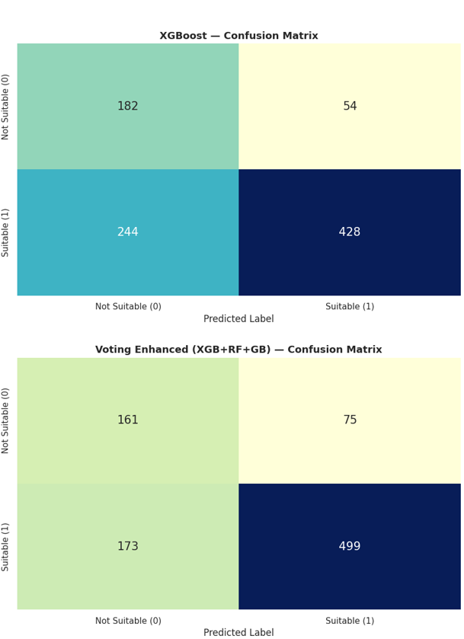

6.4 Engineering Interpretation of the System Behavior
From a data engineering perspective, the system’s behavior can be decoded through optimized feature dimensionality and soft probability calibration. By abstracting the high-dimensional document dense vectors into a specialized smart matrix, the system bypassed the curse of dimensionality, directly feeding clean, impactful structural tokens to the classifiers. Additionally, relying on soft probability predictions allowed the pipeline to model a flexible ranking threshold rather than outputting strict binary states. This architectural choice aligns directly with commercial recruitment platforms where ranking reliability is prioritized over raw metrics.

6.5 Strengths and Potential Constraints
The key strengths of the model include highly responsive talent retrieval rates suitable for massive enterprise screening, resilient semantic alignment across varying data formats, and optimized model transparency achieved by presenting structural features alongside confidence metrics. However, potential constraints show that the system performance remains dependent on the quality of initial text parsing engines, and the classification acceptance boundaries require minor adjustments when deployed within niche or highly proprietary engineering domains.

6.6 Future Enhancements
The operational efficiency of the system can be advanced through the integration of multi-modal feature expansion, such as automated parsing pipelines for professional certifications and specialized continuous academic verifications. Additionally, applying localized weights to the foundational model using corporate text corpora directly sourced from regional employment markets, or incorporating Isotonic Regression to further calibrate the confidence intervals of the voting head outputs, will significantly improve future performance.

6.7 Future Research Orientations
The core discoveries of this project open up several academic and empirical research trajectories, including the exploration of Large Language Models to function as zero-shot ranking agents embedded within the retrieval loop. Researchers can also incorporate role transition probabilities and corporate tenure metrics to predict structural career longevity, alongside implementing automated bias mitigation layers to protect candidate demographics and ensure algorithmic fairness in screening operations.

6.8 Conclusion
The empirical findings prove that integrating dense linguistic representations with optimized tabular ensemble frameworks yields an industrial-grade, reliable recruitment asset. The system successfully demonstrates that automated, AI-driven architectures can significantly reduce manual processing costs during initial screening phases while maintaining high accuracy and protecting the integrity of candidate matching lists.

Table of content

Term / Concept | Definition
Resume / CV | A document summarizing an individual's educational background, work experience, skills, and personal information, used when applying for jobs.
Job Description | A document issued by an employer specifying required skills, qualifications, tasks, and responsibilities for a position.
ResumeScreening | The process of evaluating and filtering job applicants based on specified criteria to identify the most suitable candidates.
Unstructured Text | Free-form text without fixed fields, such as PDF files or full resume texts.
Structured Data | Data in clearly defined fields such as skills, education, and years of experience.
Natural Language Processing (NLP) | Techniques for computationally understanding and analyzing human-written text.
Deep Learning | Models based on deep neural networks used to understand complex patterns.
Transformer | A modern NLP architecture that relies on attention mechanisms to understand context.
Attention Mechanism | A mechanism that determines which parts of a text are most important during comprehension.
Self-Attention | Each word attends to other words to determine its meaning within context.
Encoder | The component that converts text into numerical representations (Embeddings).
Decoder | A component typically used in text generation (not always required for similarity tasks).
Embedding | Converting text into a numerical vector carrying semantic meaning.
Sentence Embedding | A fixed-length embedding representing an entire sentence or text.
Sentence-BERT (SBERT) | A BERT variant designed to produce sentence-level embeddings for comparison and similarity tasks.
all-MiniLM-L6-v2 | A lightweight and fast SBERT model that produces high-quality embeddings.
Semantic Similarity | Measuring the closeness of meaning between texts, beyond literal word matching.
Cosine Similarity | A metric measuring the angle between two vectors; closer to 1 means higher similarity.
Feature Engineering | Extracting and designing numerical features such as skill overlap and experience gap.
Skill Extraction | Automatically extracting skills from text (e.g., Python, SQL).
Named Entity Recognition (NER) | Extracting entities such as skills, certificates, and tool names from text.
Years of Experience | The number of practical years derived from work history or experience descriptions.
Experience Gap | The difference between the candidate's experience and the experience required in the JD.
Matching Ratio | The proportion of matching elements (e.g., intersecting skills vs. required skills).
Ground Truth Label | The verified reference score (0-1) used for model training.
Regression | A learning type that predicts a continuous numerical value (e.g., a score).
Ranking | Ordering candidates from best to least suitable based on their score.
Dense Layer | A Neural Network layer that converts features into a final prediction.
Loss Function | Measures model error during training to update weights.
Learning Rate | The size of the weight update step; smaller means slower but more stable training.
Epoch | A single complete pass through all training data.
Batch Size | The number of samples processed in each training step.
Train/Test Split | Dividing data to train the model and then test its generalization.
Overfitting | When a model memorizes training data and performs poorly on new data.
MAE (Mean Absolute Error) | The average of absolute differences between predicted and actual values.
RMSE (Root Mean Square Error) | Similar to MAE but penalizes larger errors more severely.
Pearson Correlation | Measures the linear relationship between predicted and actual values.
Spearman Correlation | Measures ranking quality (highly important for Ranking tasks).
Warmup Steps | Starting training with a small learning rate then gradually increasing it for stability.
Weight Decay | A regularization technique that reduces weight inflation and aids generalization.
GPU (Graphics Processing Unit) | Accelerates heavy computations during training and encoding.
Google Colab | A cloud platform for running Python with GPU support conveniently.

References

- Application of LLM Agents in Recruitment https://arxiv.org/abs/2401.04053
- Smart Resume Screening Tool using NLP https://ieeexplore.ieee.org/document/10055852
- Enhanced Resume Screening for Smart Hiring https://arxiv.org/abs/2403.01868
- Resume Screening with NLP https://arxiv.org/abs/2405.07463
- AI and Hiring: Challenges and Opportunities https://arxiv.org/abs/2303.13440
- Automated Resume Parsing Using NLP https://arxiv.org/abs/2207.01491
- A Survey on Resume Screening Using NLP and ML https://arxiv.org/abs/2309.08192
- Job2Vec: Embedding Job Descriptions for Matching https://arxiv.org/abs/2107.09228
- Semantic Matching Between Job Descriptions and CVs using Transformers https://arxiv.org/abs/2301.10728
- Skill Extraction from Job Ads using NER + BERT https://arxiv.org/abs/2205.00271
- Automatic Skill Extraction using Transformer Models https://arxiv.org/abs/2305.06712
- Learning to Rank for Talent Screening https://arxiv.org/abs/2202.05783
- Attention Is All You Need https://arxiv.org/abs/1706.03762
- BERT: Pre-training Deep Bidirectional Transformers https://arxiv.org/abs/1810.04805
- Sentence-BERT: Sentence Embeddings for Semantic Search https://arxiv.org/abs/1908.10084

